**

***Faculty of engineering - Shoubra***

***Benha University***

***Research Article / Research Project / Literature Review***

*in fulfillment of the requirements of*

|  |  |
| --- | --- |
| ***Department*** | ***Engineering Mathematics and Physics*** |
| ***Division*** |  |
| ***Academic Year*** | ***2019-2020 Preparatory*** |
| ***Course name*** | ***Computer*** |
| ***Course code*** | ***ECE006*** |
| ***Date*** |  |

***Title: -***

***Programming Languages***

*By:*

|  |  |  |  |
| --- | --- | --- | --- |
|  | *Name* | *Edu mail* | *B.N* |
| *1* | *Muhammed Ahmed El-sayed muhammed* | [*muhammed195713@feng.bu.edu.eg*](mailto:muhammed195713@feng.bu.edu.eg) | *641* |

***Approved by:***

|  |  |
| --- | --- |
| *Examiners committee* | *Signature* |
| *Dr.Ahmed Bayoumi* |  |
| *Dr.Shady Elmashad* |  |
| *Dr. Abdelhamid Attaby* |  |

|  |  |
| --- | --- |
| *Github link* |  |
| *Github page* |  |

***Application brief***

***Programming Languages:***

*Modern human life is greatly influenced by computers. And the computer is run by a computer program. Computer programs are arranged by programming languages, therefore they are the basis of all the conveniences that we feel. Programming languages are responsible for all programs that have been made;*[*rostering systems*](https://esolveroster.co.uk/)*, virtual reality, scheduling software, online games, Uber app, anti-virus and so on. Thus mastering programming languages brings one closer to understanding how all digital technology originates.*

***Examples of Programming Languages and their Uses:***

* ***Python*** *is an open-source programming language used by software engineers and back-end Web developers. Python is well-suited for scientific computing, and it is relatively simple to learn.*
* ***Java*** *is prevalent in Web-based development, and it was created in 1995. Many companies in the health sciences, education, and finance industries use Java. Java enables the downloading of applets from websites, which enable browsers to perform additional functions.*
* ***Ruby*** *is an open-source scripting language that coders can use independently or in conjunction with Ruby on Rails. NASA uses Ruby in its work with simulations.*
* ***HTML*** *is used extensively in Web development. HTML is the code that serves as the foundation of Web pages, allowing people to create and structure electronic documents for viewing online.*
* ***JavaScript*** *is used by Web developers and software engineers to manipulate page elements to make them more engaging. JavaScript enhances HTML, and it is embedded in most Internet browsers.*
* ***C*** *is a middle-level programming language used by software developers and systems analysts. Programmers use C to create applications that integrate with operating systems.*
* ***C++,*** *developed in 1983, is another middle-level programming language and works as an extension of C. Programmers use C++ to create games, graphics, and office applications.*
* ***C#*** *is a programming language used by software engineers who create applications designed to work with Windows operating systems. C# shares similarities with Java.*
* ***Objective-C*** *is an object-oriented language used by mobile developers and software engineers. Developers creating iOS and OS X utilities often use Objective-C.*
* ***PHP*** *was released to the public in 1995. Developers use PHP as an open-source language to create dynamic Web pages. Widely used platforms such as WordPress and Drupal work cohesively with PHP.*
* ***SQL*** *enables programmers to create, read, update, and delete information in a database. Companies use SQL to gather data.*
* ***Apple*** *uses the Swift programming language to create and maintain iOS and OS X applications. Swift 2 is a secondary open-source programming language more recently released by Apple.*

***Screenshots***

***Code of the min page:***

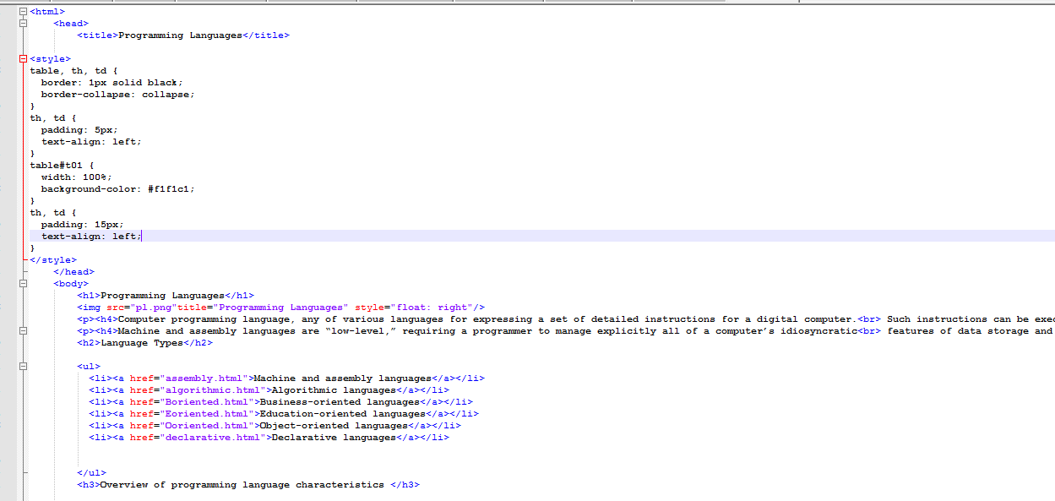

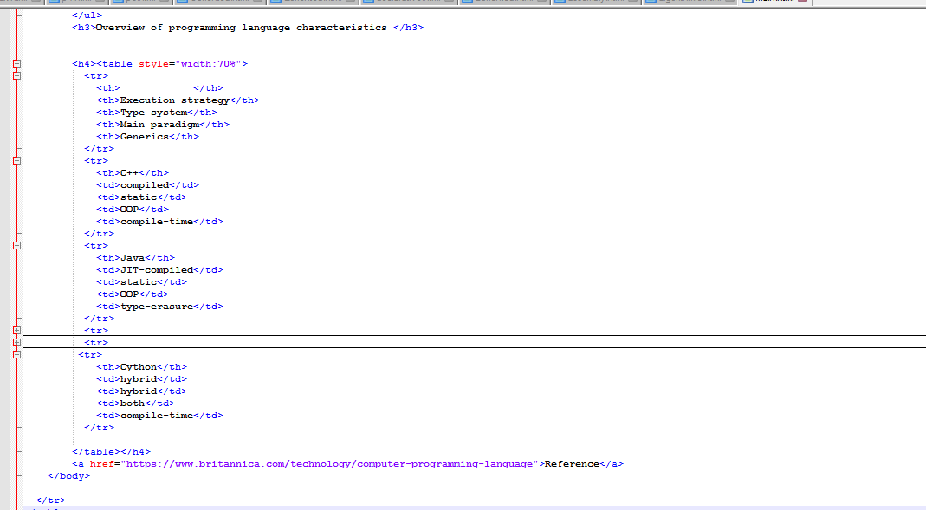

***Running of main page:***

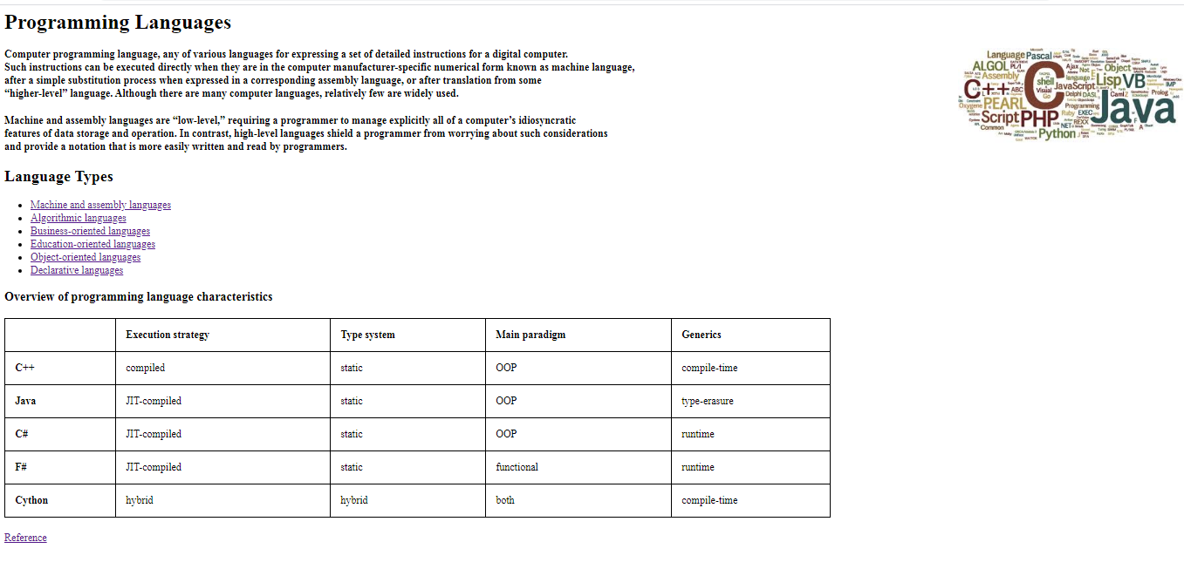

***First Link (Machine and assembly languages):***

***Code:***

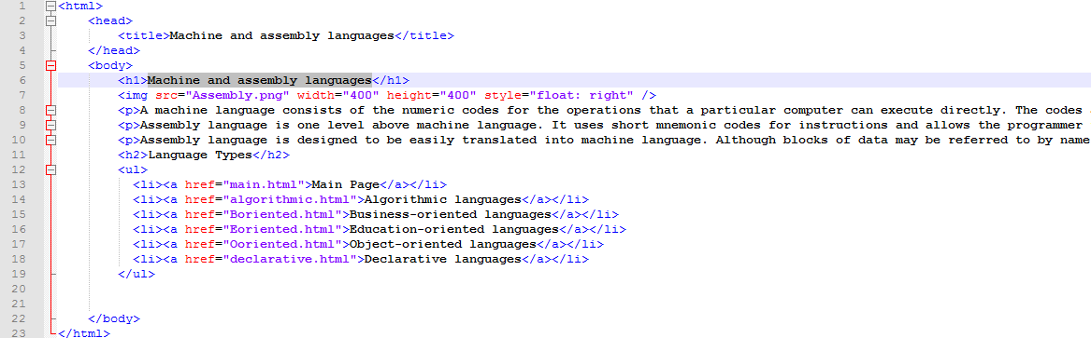

***Running:***

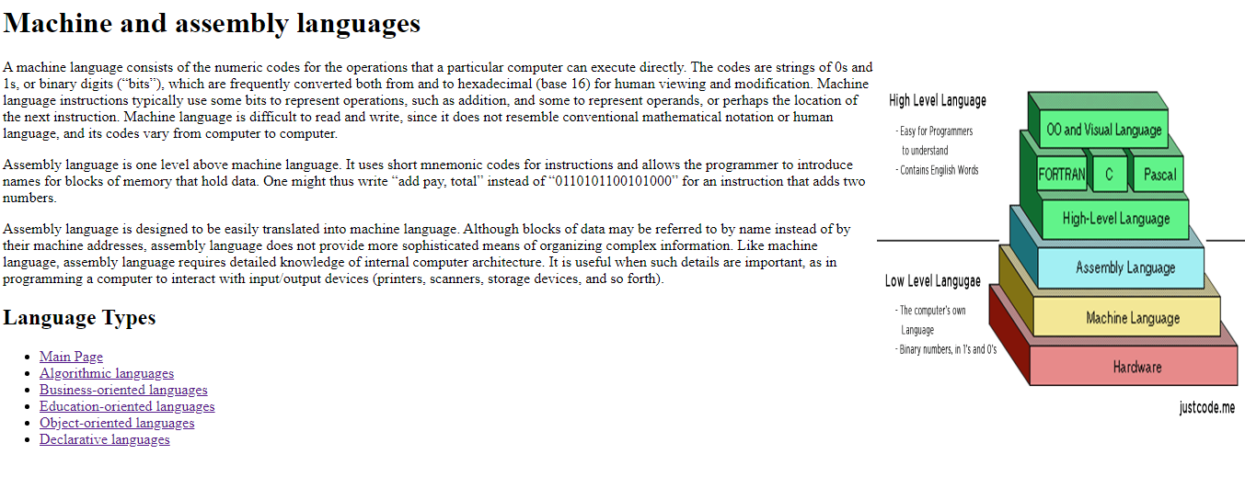

***Algorithmic languages page :***

***Code:***

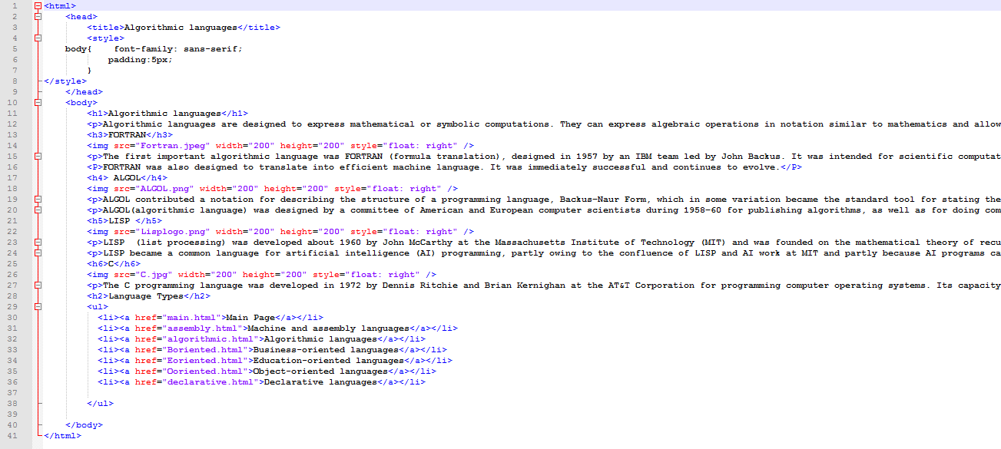

***Running:***

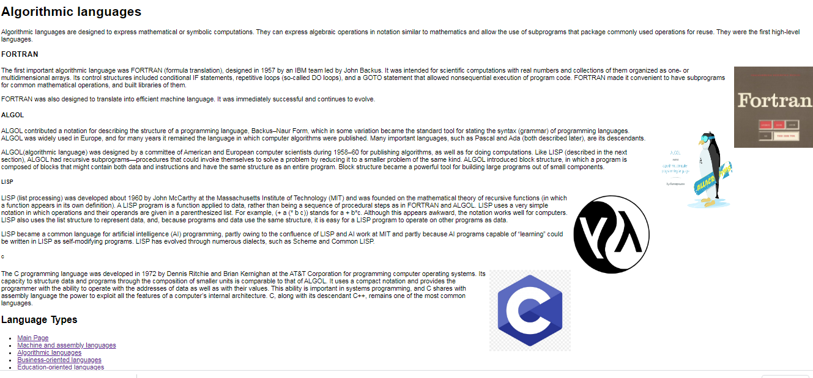

***Business-oriented languages page:***

***Code:***

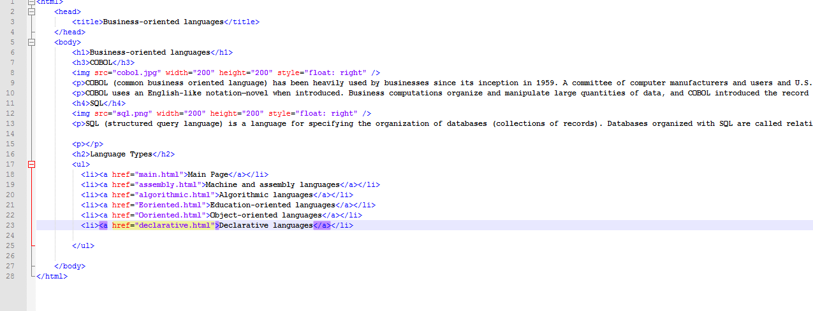

***Running:***

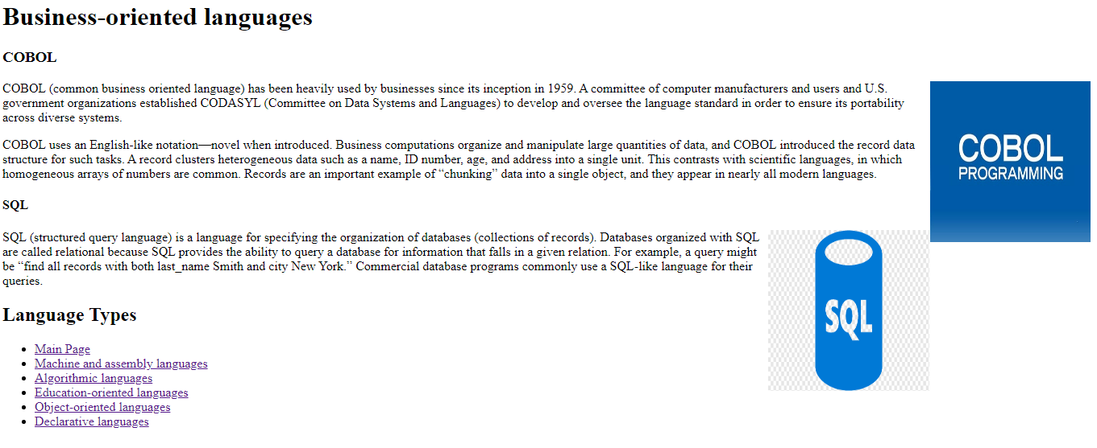

***Education-oriented languages page:***

***Code:***

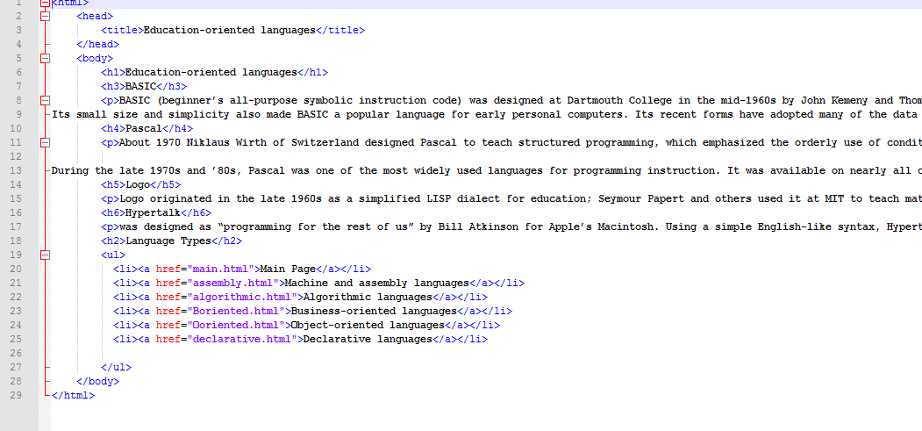

***Running:***

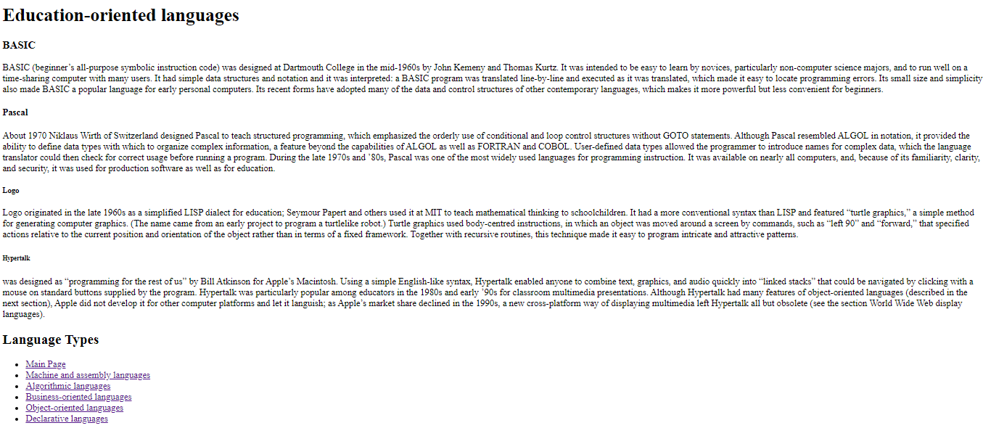

***Object-oriented languages page:***

***Code:***

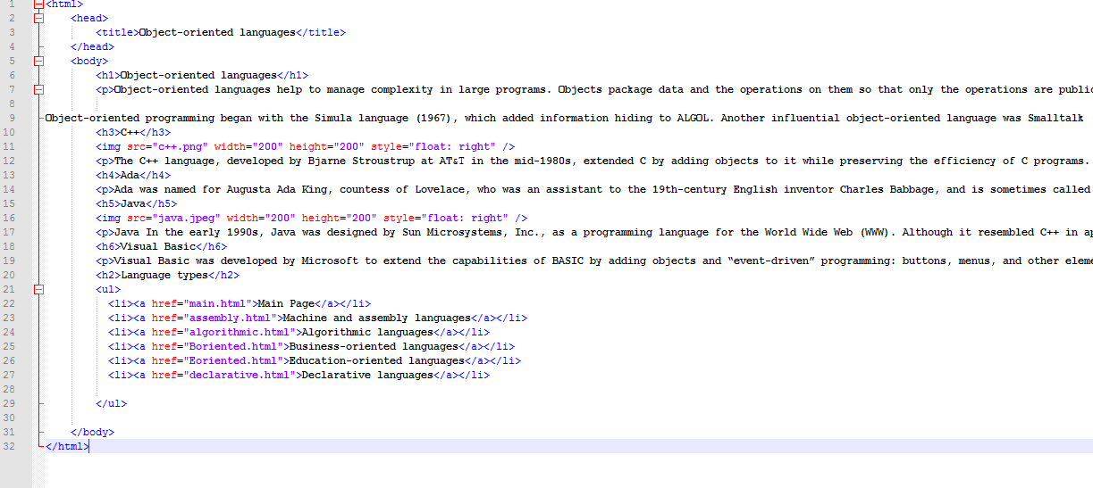

***Running:***

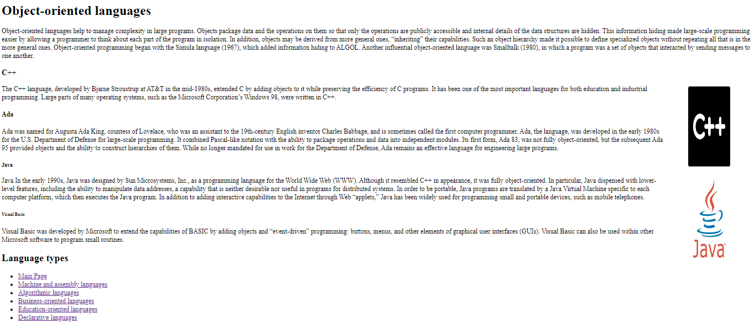

***Declarative languages page:***

***Code:***

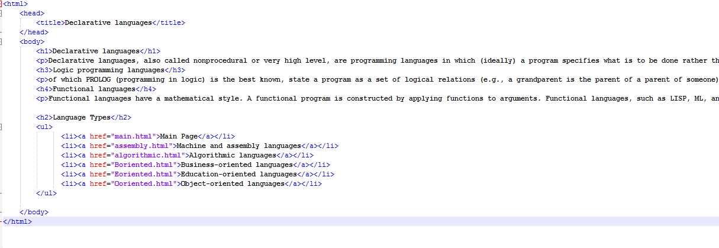

***Running:***

